Modul Number: 0750362
Module Name: Database Applications

Teacher: Eman Alnaji

Part IV
PL/SQL

What is PL/SQL?
- Procedural programming language
  - Uses detailed instructions
  - Processes statements sequentially
- Combines SQL commands with procedural instructions
- Used to perform sequential processing using an Oracle database
- PL/SQL supports variables, conditions, loops and exceptions.
- PL/SQL blocks can include control flow and DML statements.
When is PL/SQL Useful?
- When something is too complicated for SQL
- When conditional branching and looping are needed
Basic Structure:
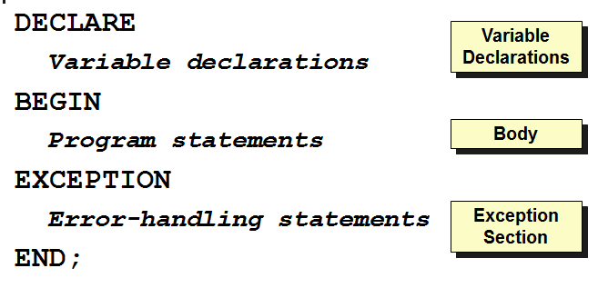

PL/SQL Program Lines:
- May span multiple text editor lines
- Each line ends with a semicolon
- Text is not case sensitive
Comment Statements:
- Block of comments are delimited with /* */
/* <comment that spans more than one line of code> */
- Single comment line starts with 2 hyphens
-- comment on a single line
Variables:
Variables can have:
- any SQL data type, such as CHAR, DATE, or NUMBER
- or any PL/SQL data type, such as BOOLEAN or BINARY_INTEGER.
- Reference data types:
  - Reference a database item
  - Assume data type of item
    - %TYPE: assumes data type of field
    - %ROWTYPE: assumes data type of entire row
- Syntax for declaring a variable:
variable_name data_type_declaration;
- Examples:
  - part_no NUMBER(4);
  - in_stock BOOLEAN;
Arithmetic Operators:
O a 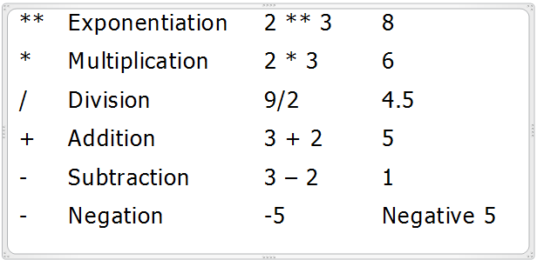
Assigning Values to Variables:
First: Assignment Statement
- Assignment operator: :=
- Variable being assigned to a new value is on left side of assignment operator
- New value is on right side of operator
student_name := ‘John Miller’;
student_name := current_student;
tax := price * tax_rate;
Second: Selecting database value into a variable.
SELECT salary * 0.10
INTO bonus
FROM employee
WHERE SSN = SSN_In;

Displaying PL/SQL Output in SQL*Plus
- Command to activate memory buffer in SQL*Plus to enable output from PL/SQL programs:
SQL> SET SERVEROUTPUT ON
- Command to output data from a PL/SQL program in SQL*Plus:
DBMS_OUTPUT.PUT_LINE(‘output string’);
DBMS_OUTPUT.PUT_LINE(‘Employee Salary: ’|| Salary);
- - || is a concatenation operator
Executing a PL/SQL Program in SQL*Plus
- Copy program code from Notepad to SQL*Plus
- Type / to execute
Character String Functions in PL/SQL
- Concatenating strings: joining 2 or more character strings into a single string
- Concatenation operator: ||
s_first_name := ‘Sarah’
s_last_name := ‘Miller’
s_full_name := s_first_name || ‘ ’ || s_last_name

PL/SQL Character String Functions
- These functions were discussed before, but here are some examples using them in PL/SQL
- RTRIM: removes blank trailing spaces
cust_address := RTRIM(cust_address);
- LENGTH: returns string length (number of characters)
address_length := LENGTH(cust_address);
- UPPER, LOWER: changes characters to all upper or lower case
s_name := UPPER(s_name);
s_name := LOWER(s_name);
- INSTR: searches a string and looks for a matching substring and returns its starting position
starting_position := INSTR(string_being_searched, search_string>);
blank_position := INSTR(‘Sarah Miller’, ‘ ’);
- SUBSTR: extracts a specific number of characters from a string, starting at a given point
extracted_string := SUBSTR(string_being_searched, starting_point, number_of_characters_to_extract);
s_first_name := SUBSTR(‘Sarah Miller’, 1,5);
NULL Values in Assignment Statements
- Until a value is assigned to a variable, the variable’s value is NULL
- Performing an arithmetic value on a NULL value always results in a NULL value
- Advice: Always initialize variable values
PL/SQL Selection Structures (IF Statement)
- IF/END IF:
IF condition THEN
program statements
END IF;
- IF/ELSE/END IF:
IF condition THEN
program statements
ELSE
alternate program statements
END IF;

- IF/ELSIF:
IF condition1 THEN
program statements;
ELSIF condition2 THEN
alternate program statements;
ELSIF condition3 THEN
alternate program statements;
. . .
ELSE
alternate program statements;
END IF;
PL/SQL Comparison Operators
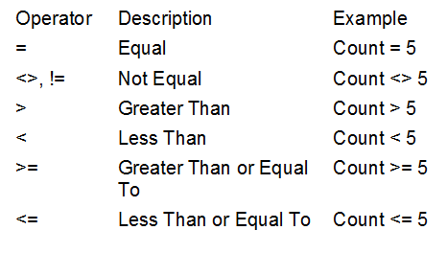
Evaluating NULL Conditions in IF/THEN Structures
- If a condition evaluates as NULL, then it is FALSE
- How can a condition evaluate as NULL?
  - It uses a BOOLEAN variable that has not been initialized
  - It uses any other variable that has not been initialized
Example:
IF acct_balance >= debit_amt THEN
UPDATE accounts SET bal = bal - debit_amt
WHERE account_id = acct;
ELSE
INSERT INTO temp
VALUES (acct, acct_balance, 'Insufficient funds');
END IF;

PL/SQL Loops
- Loop: repeats one or more program statements multiple times until an exit condition is reached
  - Pretest loop: exit condition is tested before program statements are executed
  - Posttest loop: exit condition is tested after program statements are executed
LOOP … EXIT Loop
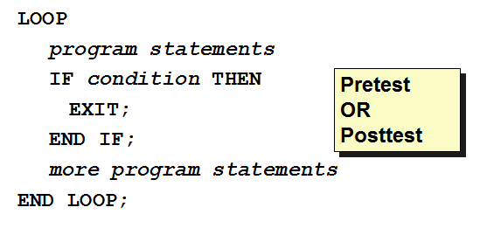
LOOP … EXIT WHEN Loop
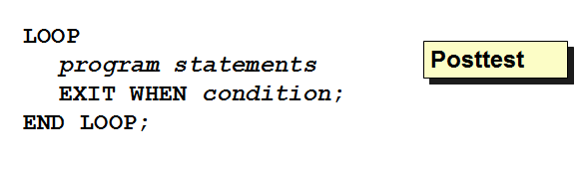

WHILE Loop
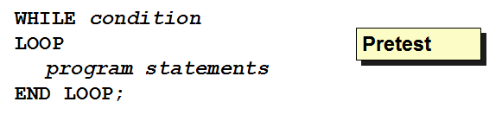
Numeric FOR Loop
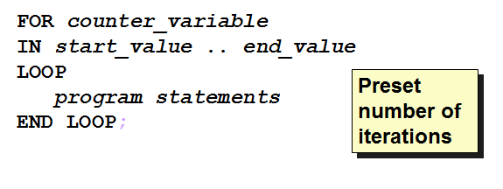
Examples:
FOR num IN 1..500 LOOP
INSERT INTO roots VALUES (num, SQRT(num));
END LOOP;

WHILE salary <= 2500 LOOP
SELECT salary, mgr_ssn, lname
INTO salary, mgr_ssn, last_name
FROM employee
WHERE ssn = mgr_ssn;
END LOOP;

Cursors
A cursor is a pointer to a private SQL area that stores results of a SELECT statement.
Types of Cursors
- Implicit
- Explicit
Implicit Cursors
- Created automatically every time you use an INSERT, UPDATE, DELETE, or SELECT command
- Doesn’t need to be declared
- Can be used to assign the output of a SELECT command to one or more PL/SQL variables
- Can only be used if query returns one and only one record
Explicit Cursors
- Must be declared in program DECLARE section
- Can be used to assign the output of a SELECT command to one or more PL/SQL variables
- Can be used if query returns multiple records or no records
Using an Explicit Cursor
- Declare the cursor
- Open the cursor
- Fetch the cursor result into PL/SQL program variables
- Close the cursor

Declaring an Explicit Cursor
DECLARE
CURSOR cursor_name IS SELECT_statement;
Opening an Explicit Cursor
OPEN cursor_name;
Fetching Explicit Cursor Records
FETCH cursor_name
INTO variable_name(s);
Closing an Explicit Cursor
CLOSE cursor_name;
Processing an Explicit Cursor
- LOOP ..EXIT WHEN approach:
OPEN cursor_name;
LOOP
FETCH cursor_name INTO variable_name(s);
EXIT WHEN cursor_name%NOTFOUND:
END LOOP;
CLOSE cursor_name;
- Cursor FOR Loop approach:
FOR variable_name(s) in cursor_name LOOP
additional processing statements;
END LOOP;
Explicit Cursor Attributes

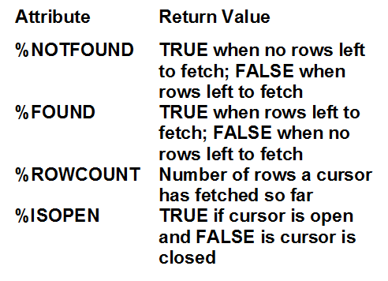
Using Reference Data Types in Explicit Cursor Processing
- Declaring a ROWTYPE reference variable:
DECLARE
reference_variable_name cursor_name%ROWTYPE;
- Referencing a ROWTYPE reference variable:
reference_variable_name.database_field_name

PL/SQL Example1:
DECLARE
Emp_name VARCHAR2(10);
Cursor c1 IS SELECT Ename FROM Emp_tab
WHERE Deptno = 20;
BEGIN
OPEN c1;
LOOP
FETCH c1 INTO Emp_name;
EXIT WHEN c1%NOTFOUND;
DBMS_OUTPUT.PUT_LINE(Emp_name);
END LOOP;
END;
PL/SQL Example2:
DECLARE
Emp_number INTEGER := 9999;
Emp_name emp.empname%type;
BEGIN
SELECT Ename INTO Emp_name
FROM Emp_tab
WHERE Empno = Emp_number; -- no such number
DBMS_OUTPUT.PUT_LINE('Employee name is ' || Emp_name);
EXCEPTION
WHEN NO_DATA_FOUND THEN
DBMS_OUTPUT.PUT_LINE('No such employee: ' || Emp_number);
END;

PL/SQL Example3:
DECLARE
CURSOR c1 is
SELECT fname, ssn, salary FROM employee
ORDER BY salary DESC; --start w/ highest paid emp
my_ename VARCHAR2(10);
my_empno CHAR(9);
my_sal NUMBER(10,2);
BEGIN
OPEN c1;
FETCH c1 INTO my_ename, my_empno, my_sal;
WHILE C1%FOUND LOOP
DBMS_OUTPUT.PUT_LINE (MY_EMPNO||','||MY_SAL);
UPDATE employee
SET salary = salary * 1.1
WHERE ssn = my_empno;
/*By this statement you will update only the employees retrieved by the cursor.*/
FETCH c1 INTO my_ename, my_empno, my_sal;
END LOOP;
CLOSE c1;
COMMIT; /* This will save all updates applied on Employee table */
EXCEPTION
WHEN OTHERS THEN
ROLLBACK;
/*If any error occurred, any updates applied on the employee table will not be saved and reversed as the state it was before applying this program */
END;
PL/SQL Exception Handling
- All error handling statements are placed in the EXCEPTION program block
- Exception handler: program command that provides information about an error, and suggest correction actions
Predefined Exceptions
- Common errors that have been given predefined names that appear instead of error numbers
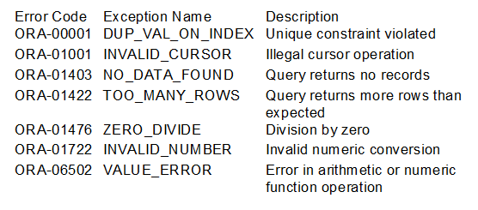

Exception Handler Syntax for Predefined Exceptions
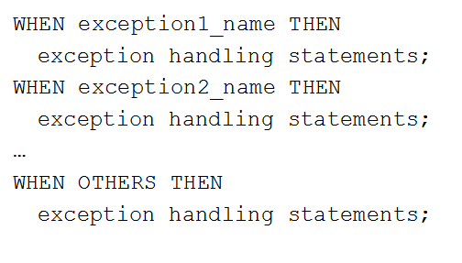
Exercise:
Apply the following:
- Create a new table: Employee2 (
  - Fname, LName, SSN, Salary, Salary2, Dsc
Write a PL/SQL block that applies the following:
- For each employee (in the original table employee), insert a new record in table employee2, with the same information (fname, lname, ssn, salary), and compute salary2 and dsc, as follows:
  - If the employee worked more than 40 hours on all projects
    - Put “Good” in his description and give him a 10% raise
  - Otherwise: Put “Bad” in his description
- Find the employee with the highest salary and print his name and SSN
- Display the name and salary of employee with SSN “111997788”.
  - If no employee has that SSN, display “Employee not found”

